TUTORIAL ANGULAR/CLI

INSTALA ANGULAR/CLI - OU ATUALIZA EXISTENTES:
npm install –g @angular/cli
ou/ npm install

CRIA UM NOVO PROJETO:
ng new escola-app

INICIA COMPILADOR:
npm run build

INICIA PROJETO:
npm start

CHAMA FORMULARIO (app.mudule.ts):
import { FormsModule} from '@angular/forms'
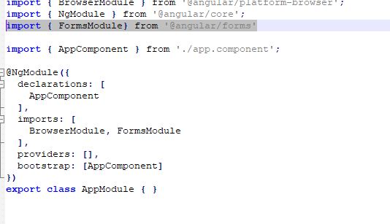
CRIA UM COMPONENT:
ng generate component ListaDeDisciplinas

INSTALA PACOTES DO BOOTSTRAP:
npm install --save bootstrap font -awesome ngx-bootstrap
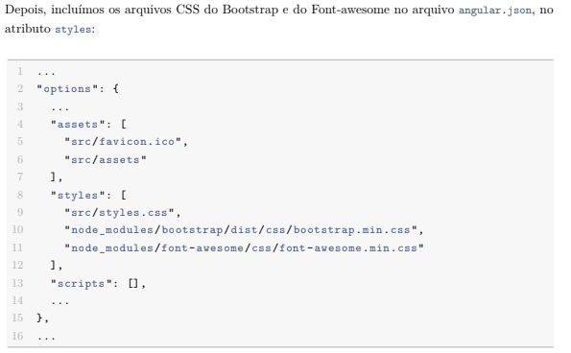
CRIA SERVIÇO:
ng g s NoticiasManager
Adicione a linha chamando o serviçe(app.component.ts):
import { QuestionarioManagerService } from './questionario-manager.service'

